Assignment 7

FILES INCLUDED

Makefile: Contains instructions to create and run the executables for the lex and yacc file

a7_220101122.y: YACC file containing the code for the parser

a7_220101122.l: Flex file for the lexical analyser

reductions_output.txt: Contains the reductions done during parsing

symbol_table_output.txt: Contains the symbol table generated during parsing

INSTRUCTIONS

Use the Makefile to generate the files

Run the executable using the following instruction:

./a7_220101122 < microc_test.mc

KEY MODIFICATIONS

Float handled similarly to the description in the assignment.

Bool handled separately with token definitions given by:

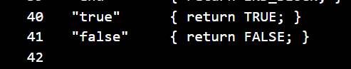

Modifications to given grammar:

1) Transition unit expression extended to allow for multiple function definitions and declarations (each starting from a new transition unit as start symbol)

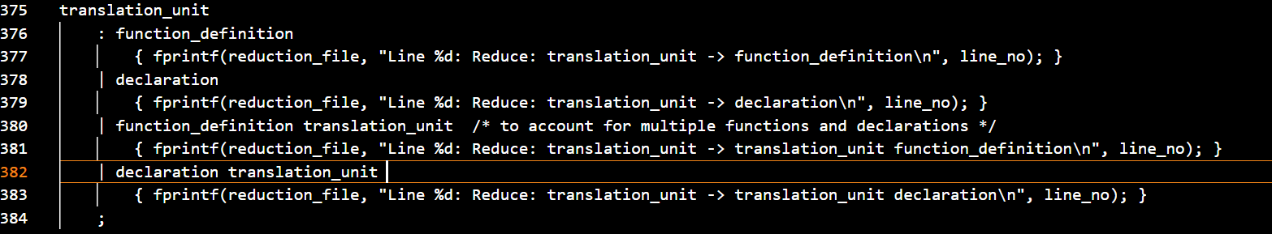

2) (Logically same as pointer_opt but distinction made to save changes to symbol table)

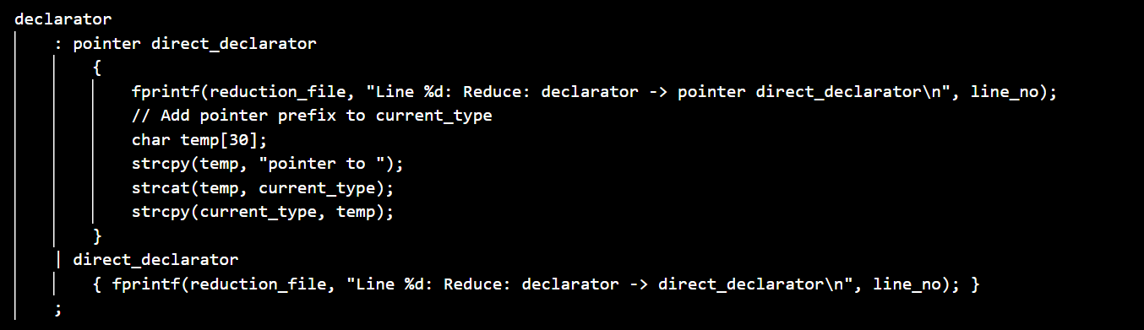

3) (Logically same as pointer_opt identifier_opt but changes made since IDENTIFIER logic requires symbol table changes as well)

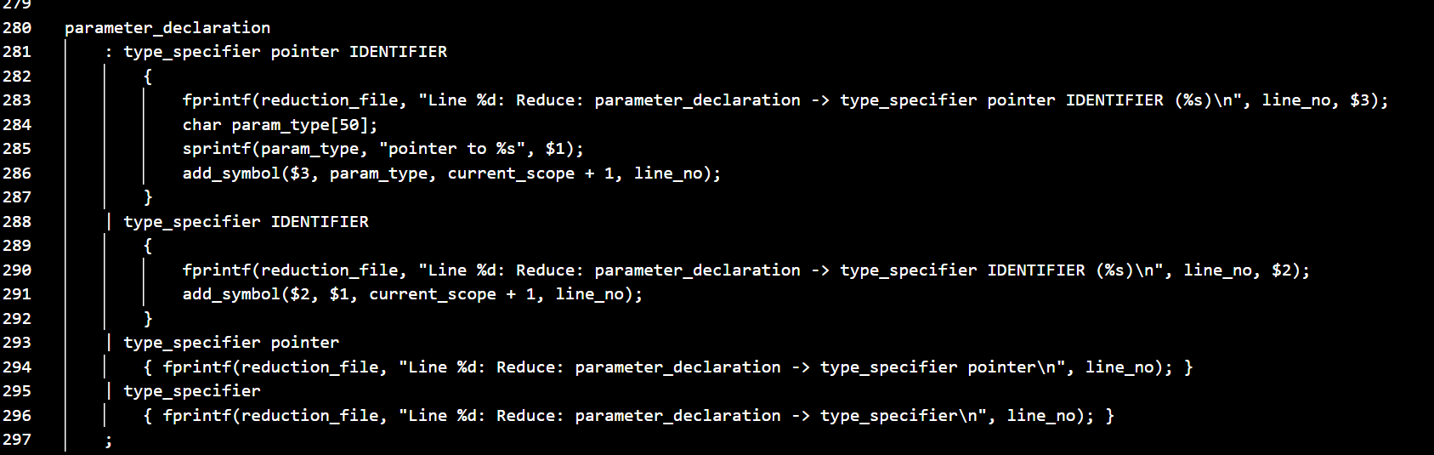

4) (Logically same as parameter_list_opt, change done to avoid reduce-reduce conflict)

